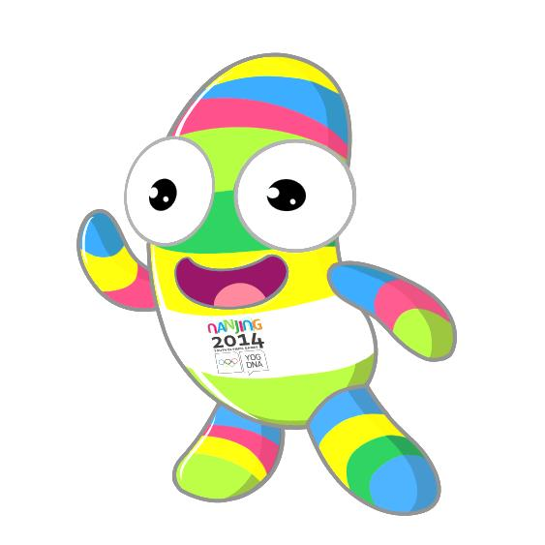
Hey there!

Join us in Nanjing!
Share the Games and Share our Dreams with other Young Ambassadors from all over the world and experience the unique DNA of the Youth Olympic Games.

National Olympic Committee of: | AUSTRIA

Young Ambassador personal details:

Family Name |  | Given Name(s)
Date of Birth | __ / __ / ____ | Nationality
Gender | ☐Female ☐Male | Current occupation (student, employee, professional athlete, etc.)
T-shirt size | ☐S ☐M ☐L ☐XL ☐XXL | Education
Permanent address |  | Phone numbers (Home, Mobile)
 |  | Email
 |  | Your social media  (username or homepage) | Facebook:  Blog:  Skype:  Twitter:  Instagram:  Others:

Language  (1=poor / 5=excellent) | Speaking | Writing | Reading
English | 1 / 2 / 3 / 4 / 5 | 1 / 2 / 3 / 4 / 5 | 1 / 2 / 3 / 4 / 5
 | 1 / 2 / 3 / 4 / 5 | 1 / 2 / 3 / 4 / 5 | 1 / 2 / 3 / 4 / 5
 | 1 / 2 / 3 / 4 / 5 | 1 / 2 / 3 / 4 / 5 | 1 / 2 / 3 / 4 / 5
 | 1 / 2 / 3 / 4 / 5 | 1 / 2 / 3 / 4 / 5 | 1 / 2 / 3 / 4 / 5

Current Activities:
Professional activities
Sport involvement
(as athlete, coach, volunteer)
Charity and community involvement

Background / Interest / Passion:
Previous Olympic and/or sports experience
Career objectives
Other skills (art, music)
Describe yourself in two words
What colour reflects you the most? | Black Brown Green Yellow Purple  Red Blue Orange Pink White  Choose a color below

Please attach your photo here:

Please send the completed form, together with a letter of motivation (in English) to Mr. Florian Kogler (Österreichisches Olympisches Comité, z.H. Florian Kogler,
Rennweg 46-50/1/7, 1030 Wien; kogler@olympia.at) by October 15, 2013.

